

Class and Characteristics

Document Control

Prepared by:
Version | Date | Name
1.0 | 01/22/2025 | MARIAM FATMA
2.0

Reviewed by:
Version | Date | Name
1.0 | 01/23/2025 | NIKHIL KOOLWAL, SRINIVAS RAO PATHI, VIJAY PATIL
2.0

Reference Documents

The following section describes relevant documentation:

Document Name | Description | Sharepoint Link
Class and Characteristics | Defining and specifying the characteristics of a class | Class and Characteristics.pdf

Contents

1.Class and Characteristics 4
1.1 Steps to create Characteristic 4
1.2 Steps to create Class 6
1.2 Steps to Assign Characteristics to the Class 8

1.Class and Characteristic

  - Steps to create Characteristic

- In the SAP Easy Access Screen, enter T-code CT04 in the command field and press enter.
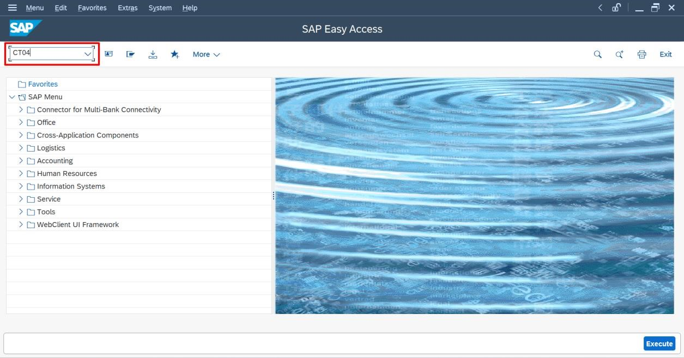
- Enter the Characteristic Name and click on create icon.
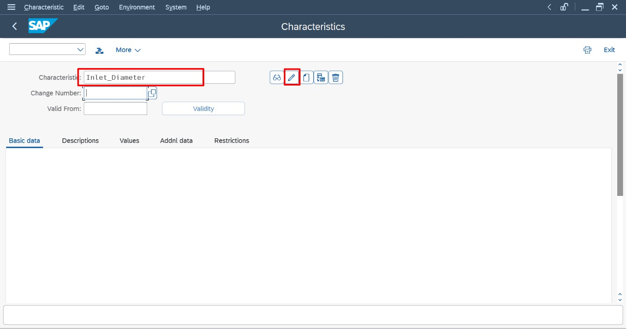
- Click on Yes
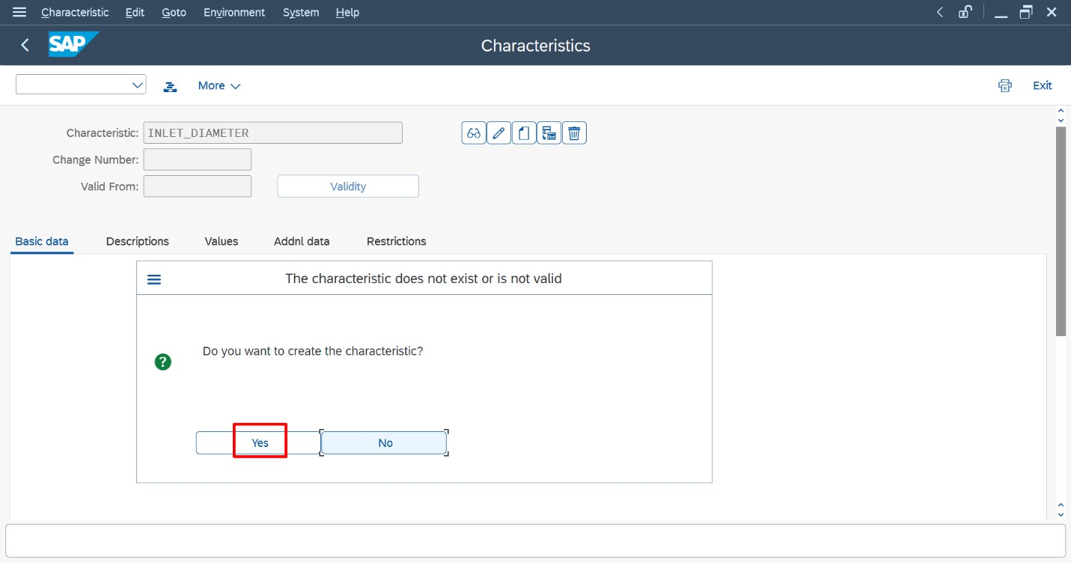
- Provide a short description for the characteristic. In format tab enter the details such as data type, number of chars and unit of measure. After entering the required information, click the save button.

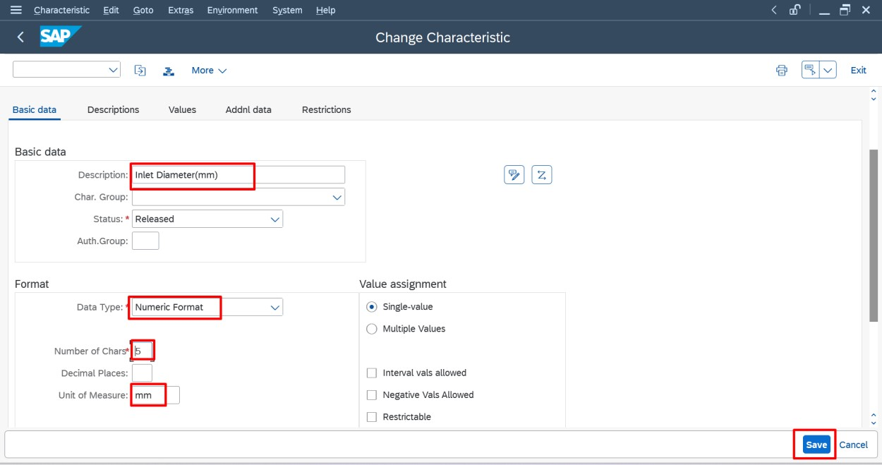
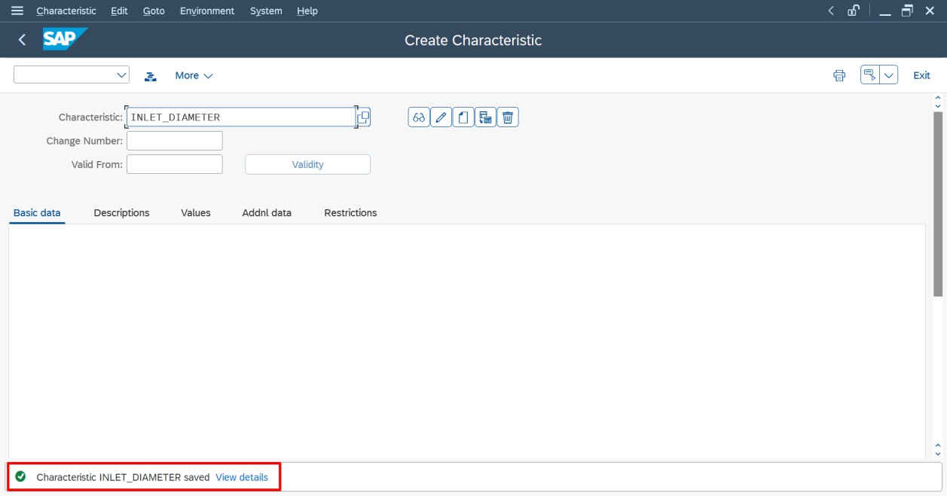

1.2 Steps to create Class

- Enter T-code CL01 in the command field and press enter.

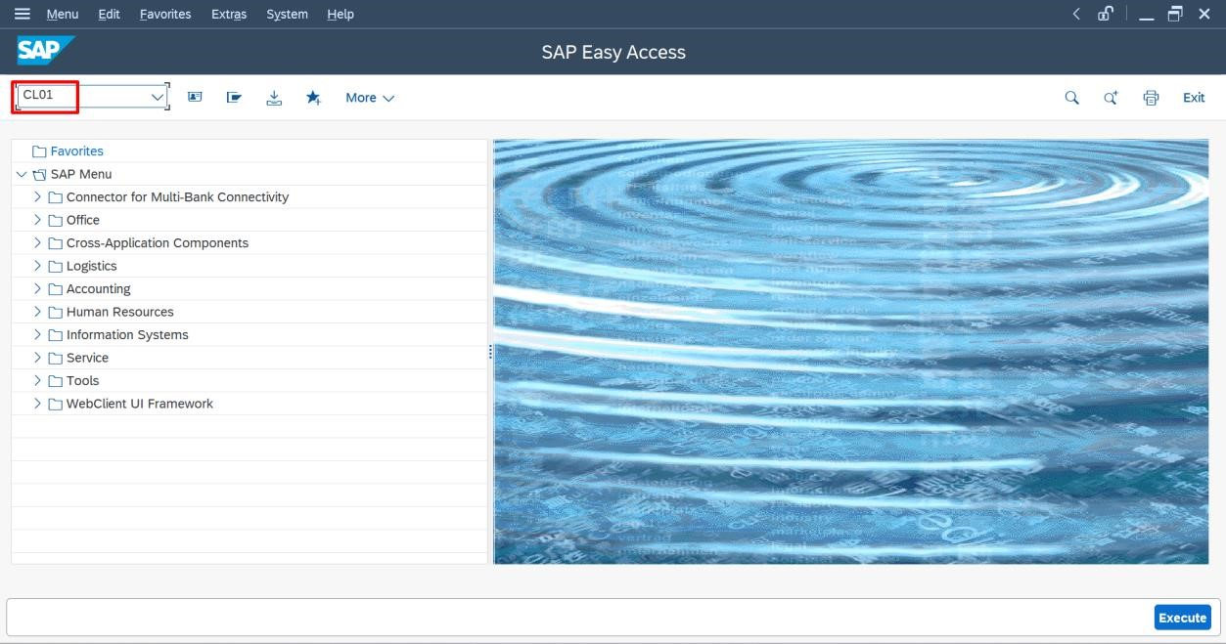
- Enter the class name and the class type and press enter.
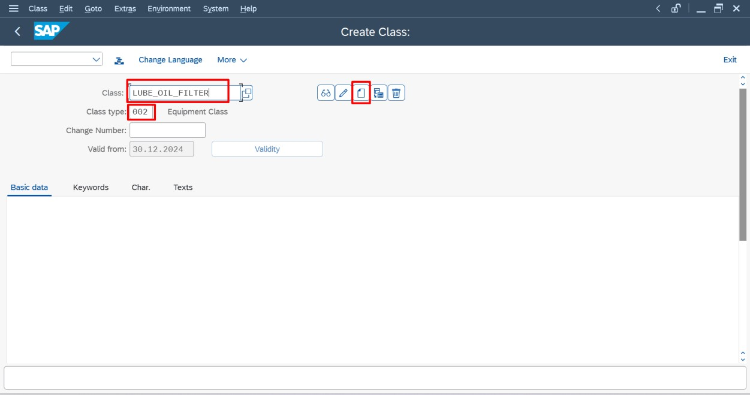

- In the description field, enter a relevant description (e.g., Lube Oil Filter) and save the class by clicking the save button.

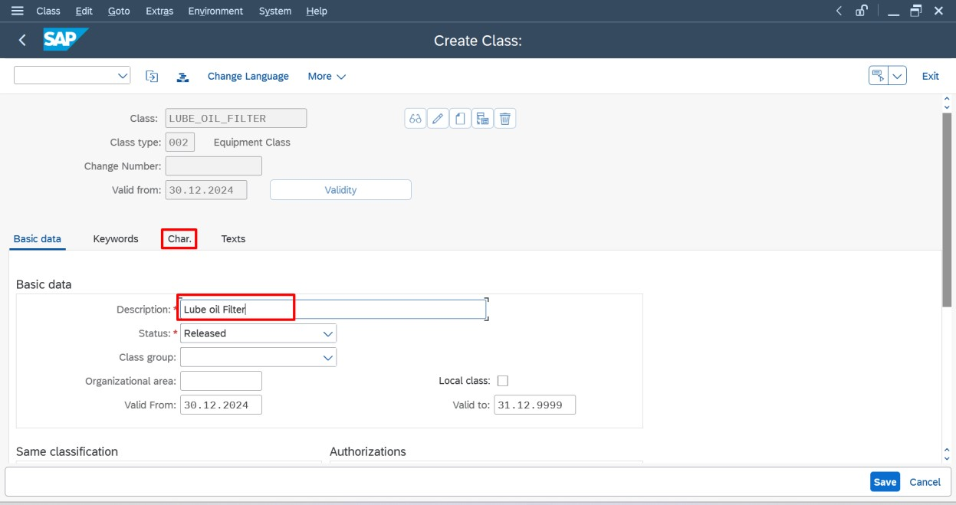
  - Steps to Assign Characteristics to the Class

- Now you need to assign the characteristic to the class you created
(e.g., LUBE_OIL_FILTER). Navigate to the "Characteristics" tab.

- Use the input field to search and assign the previously created characteristic(s). You can select multiple characteristics if needed.

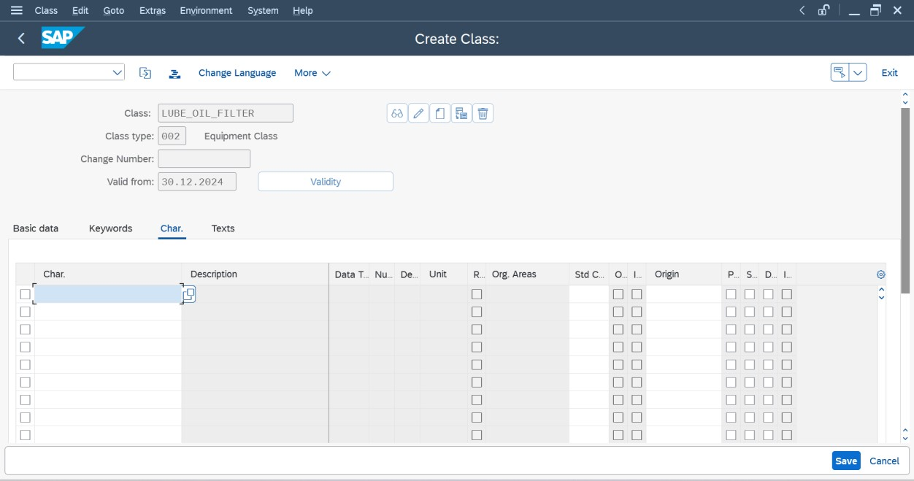

- Once added, click save to save the changes.
